**ShopNest Retail Dashboard Report**

Business Intelligence Analysis Using Power BI

Prepared by

**Km Anamika Tripathi**

Business/Data Analyst

14 June 2025

**Project Overview:**

This project presents a detailed Power BI dashboard developed to analyze the retail performance of ShopNest, an e-commerce platform. The primary objective is to transform raw sales, order, and customer data into actionable insights that support strategic business decisions. The dashboard is structured to answer key business questions related to sales performance, delivery efficiency, customer preferences, and revenue trends.

Using interactive visuals, the report covers the following core analysis areas:

* **Top Categories by Sales**
* **Delayed Orders by Category and Month**
* **Monthly Comparison of On-Time vs Delayed Orders**
* **Payment Method Preferences**
* **Top and Bottom Rated Products**
* **State-wise Sales Distribution**
* **Quarterly Seasonal Sales Trend**
* **Yearly Revenue Growth**

By leveraging Power BI’s capabilities such as slicers, drillthrough, and custom visuals, the dashboard provides an intuitive and dynamic user experience.

**Data Sources**

|  |  |
| --- | --- |
| **Dataset Name** | **Description** |
| **geolocation_dataset** | geolocation_zip_code_prefix, geolocation_lat, geolocation_lng, geolocation_city, geolocation_state |
| **customer_dataset** | customer_id, customer_zip_code_prefix, customer_city, customer_state |
| **order_items_dataset** | Order_id, freight_value,order_item_id, product_id,  Seller_id, shipping_limit_date, price |
| **order_payments_dataset** | Order_id, payment_installments, payment_sequentia, payment_type, payment_value |
| **order_review_dataset** | Review_id, order_id, review_score, review_answer_timestamp, review_commet_title, review__comment_message, review_creation_date |
| **order _dataset(1)** | Order_id, customer_id, order_status, order_purchase_timestamp, order_approved_at, order_delivered_carrier_date, order_delivered_customer_date, order_estimated_delivery_date |
| **products_dataset** | Product_id, product_category_name, Product _name_lenght , Product _description_lenght, Product _photos_qty, Product _weight_g, Product _length_g, Product _length_cm, Product _height_cm, Product _width_cm |
| **seller_dataset** | Seller_id, seller_city, seller_state, seller_zip_code_prefix |
| **Product_category_name_translation** | product_category_name, product_category_name_english |

**1. Top Categories by Total Price:**

**Insight & Analysis**

Identify and Visually represent the Top 10 product Categories by Total Sales.

Visualization Used:

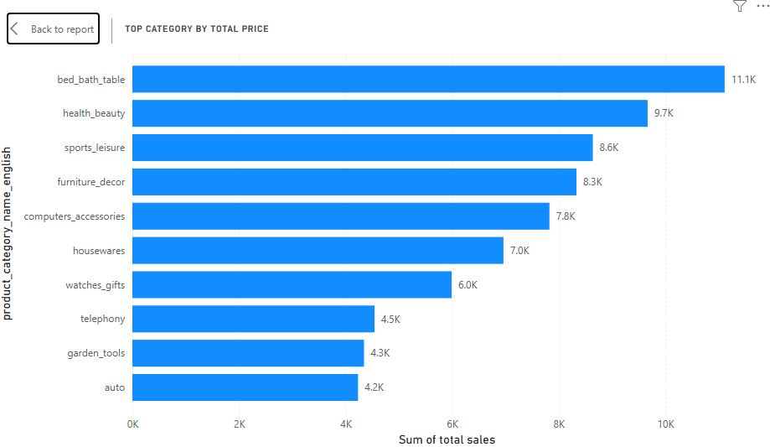

Type: “Stacked Bar Chart”

Y-axis: Product_Categeory_name_english

X-axis: Total Sales with sum measure

**Formula:**

Total sales = order_items_dataset[Total Price]/ order_items_dataset[Total Revenue]

**Insight:** This visual highlights the top 10 product categories by total sales value on the ShopNest platform. The Total Sales measure was calculated using the sum of product prices from the order items dataset. Categories such as health_beauty, watches_gifts, and bed_bath_table emerged as the top-performing segments. This analysis helps identify high-revenue categories, enabling strategic focus on best-selling product lines for inventory planning, marketing campaigns, and revenue optimization.

**2. Delayed Orders Analysis:**

Determine the number of delayed orders in each category. An order is Considered delayed if the actual delivery date is later than the estimated delivery date.

Visualization Used:

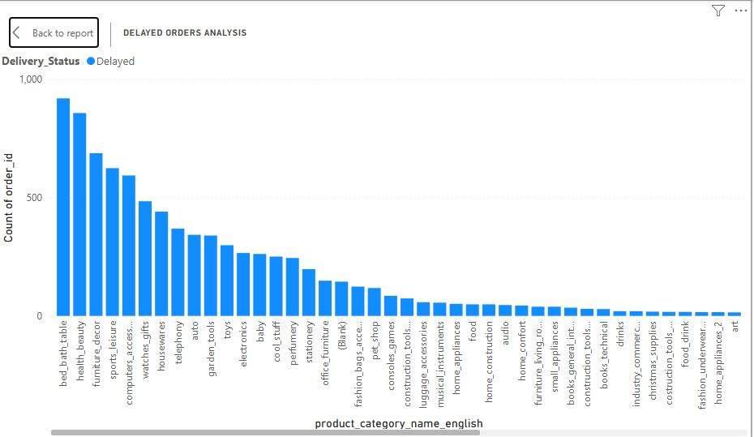

Type: “clustered Column Chart”

X-axis: Product_Categeory_name_english

Y-axis: Order_id with count measure

Legend: Delivery_status

**Formula:**

Delivery_Status = IF(' orders_dataset (1)'[order_delivered_customer_date]> ' orders_dataset (1)'[order_estimated_delivery_date],"Delayed" , "On-Time")

**Insight:** This visual illustrates the number of delayed orders across product categories, where a delivery is considered delayed if the actual delivery date exceeded the estimated delivery date. The column chart shows that bed_bath_table and health_beauty have the highest number of delays, with 920 and 858 orders respectively. This insight helps identify categories with potential logistics or fulfillment challenges, enabling ShopNest to improve delivery accuracy, enhance customer satisfaction, and refine operational efficiency across critical product segments.

**3. Monthly Comparison of Delayed On-Time Orders:**

Create a dynamic visual that compares the number of delayed orders to the number of orders received earlier for each month. Utilize the drillthrough cross-report feature to provide a detailed analysis of late and on-time deliveries.

1. Visualization Used :

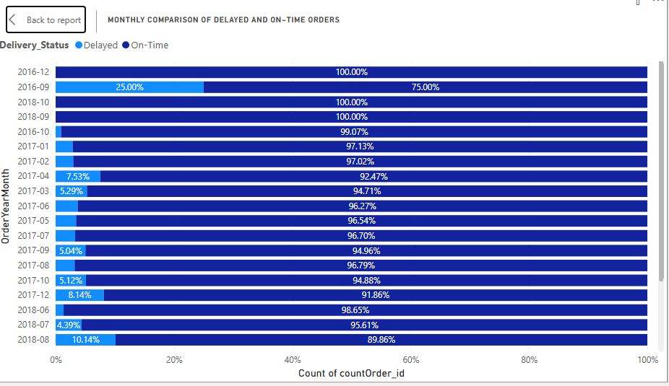

Type: “100% Stacked Bar Chart”

Y-axis: OrderYearMonth

X-axis: Order_id with count measure

Legend: Delivery_status

**Formula:**

Delivery_Status = IF(' orders_dataset (1)'[order_delivered_customer_date]> ' orders_dataset (1)'[order_estimated_delivery_date],"Delayed" , "On-Time")

OrderYearMonth = FORMAT(' orders_dataset (1)'[order_purchase_timestamp],"yyyy-mm")

**Insight :** This 100% stacked bar chart presents a monthly breakdown of delayed vs. on-time orders across the year. to optimize fulfilment. Drill-through features offer deeper insights at the individual order level for root cause analysis.

1. Visual:

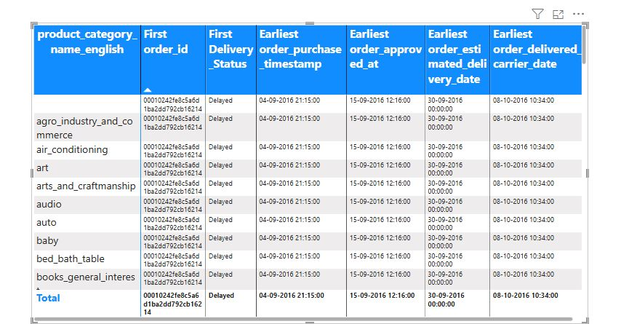

Type: “Matrix”

Rows: year

Value: Order_id with First measure

Delivery_status with First measure

Order_item_id with count measure

DrillThrough: Delivery_status with All function

**Formula:**

Delivery_Status = IF(' orders_dataset (1)'[order_delivered_customer_date]> ' orders_dataset (1)'[order_estimated_delivery_date],"Delayed" , "On-Time")

**Insight** Drill-Through: Daily Analysis of Delayed and On-Time Orders This drill-through report provides a granular day-wise breakdown of delayed and total orders across months and years. Users can explore specific time periods, for instance August 2017, to assess how delivery performance fluctuated daily. This detailed view empowers ShopNest to pinpoint operational bottlenecks, identify high-delay days, and take corrective actions. By offering interactive drill-down capabilities, it enhances the depth of analysis beyond monthly aggregates and supports more targeted supply chain improvements.

**4. Payment Method Analysis:**

Analyze the most frequently used payment methods by customers using a visually appealing representation, such as a pie chart or other suitable chart.

Visualization Used : 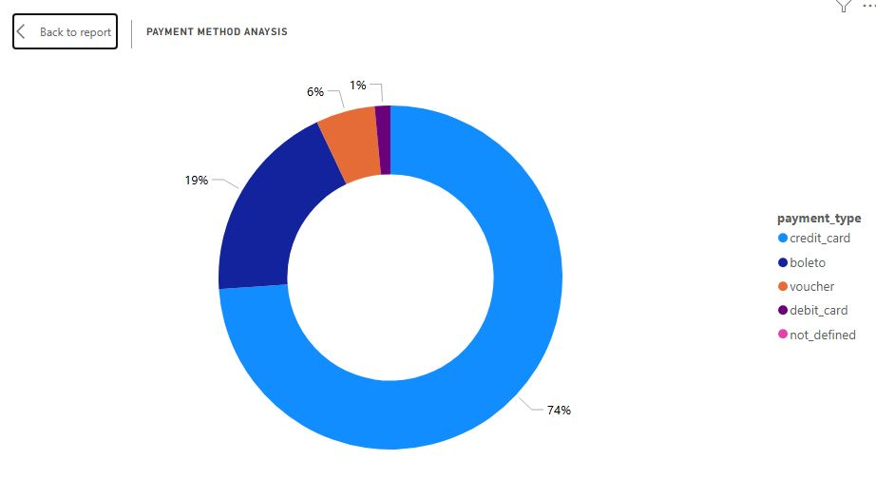

Type: “Donut Chart”

Values: paymentcount with count measure

Legend: Payment_Type

**Formula:**

PaymentCount = COUNT( order_payments_dataset[payment_type])

**Insight:** This analysis examines the most frequently used payment methods by customers on the ShopNest platform. By identifying customer preferences in transaction types, we gain valuable insights into purchasing behaviour and operational efficiency. A donut chart was used to visually represent the distribution of payment methods. Each segment of the chart indicates the proportion of total orders associated with a specific method, such as Credit Card, Boleto, voucher, or debit card etc.

**5. Product Rating Analysis:**

Determine the Top 10 highesr-Rated products and the bottom 10 lowest Rated products using a bar or colum chart.

i.Visualization Used :Top 10-highest rated products

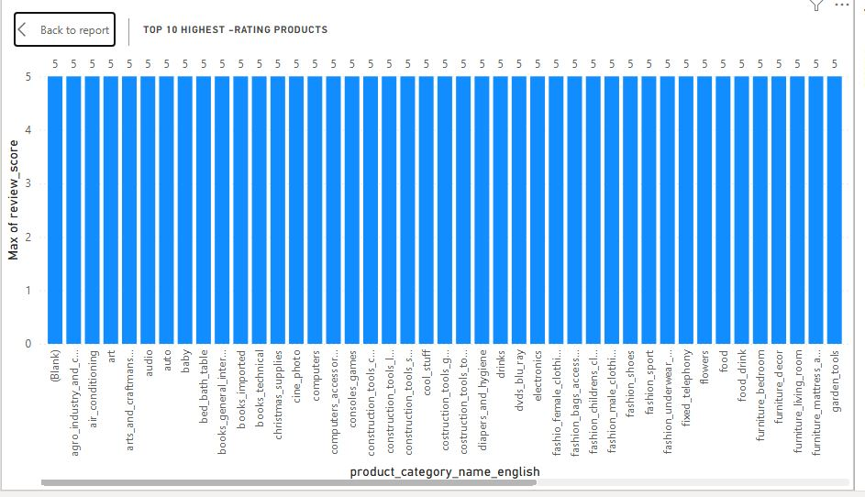

Type: “Skated Column Chart”

Values: Product_category_name_english

Legend: Maximum of review_score

Filter section: Top N Filter was applied

**Formula:**

Average Rating = AVERAGE( order_reviews_dataset[review_score])

**Insight:** The chart displays the top 10 highest-rated products, each receiving a perfect rating of 5.0, indicating maximum customer satisfaction. These consistently top-rated products highlight excellent performance in quality, functionality, and customer service. Their high ratings can serve as benchmarks for other products and are ideal candidates for promotion and upselling strategies. The fact that multiple products have perfect scores suggests effective product listing, good delivery experience, and alignment with customer expectations. Understanding what makes these products successful could help drive improvements in the broader catalogue and refine vendor or seller performance benchmarks.

ii. Visualization Used : Bottom 10 lowest- rated products 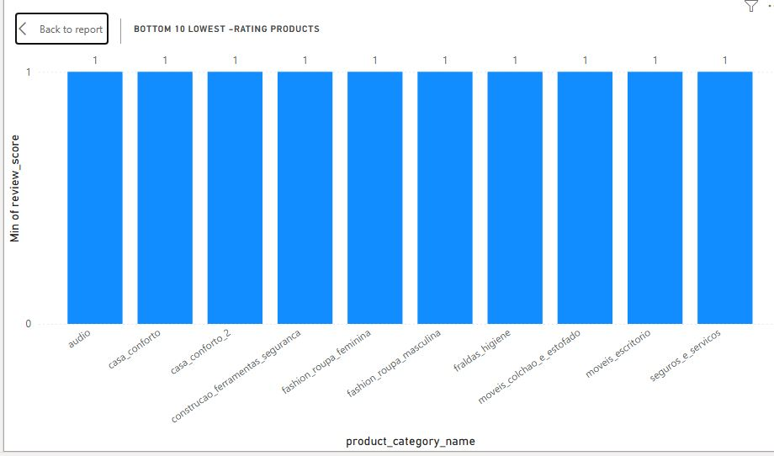

Type: “Skated Column Chart”

Values: Product_category_name_english

Legend: Minimum of review_score

Filter section: Bottom N Filter was applied

**Formula:**

Average Rating = AVERAGE( order_reviews_dataset[review_score])

**Insight:** The bottom 10 lowest-rated products all share a consistent rating of 1.0, indicating significant dissatisfaction among customers. These low scores may result from poor product quality, misleading descriptions, damaged goods, delayed shipping, or lack customer service. This clear underperformance flags them as high-risk items that could harm brand trust and loyalty if not addressed. Immediate investigation and corrective actions—such as reviewing seller practices, issuing refunds, improving logistics, or even removing certain listings—are essential. These insights also provide a roadmap for quality control and process optimization across product categories.

**6. State-Wise Sales Analysis:**

Identify and visually represent states with high and low sales. Providing a clear understanding of regional sales performance.

Visualization Used :

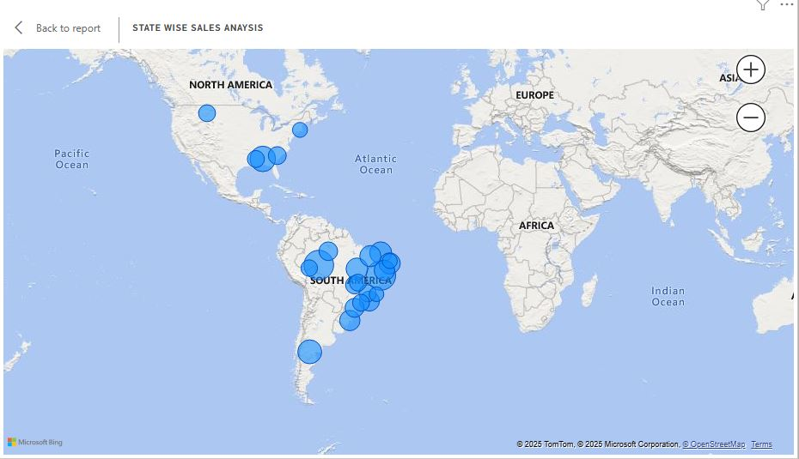

Type : “Filled Map”

Location : Customer_state

Bubble Size: Average of Total Revenue

**Insight:** The map visual depicts state-level sales performance across various global locations, with a concentration in South America—particularly Brazil—indicating higher sales volumes. Each blue bubble represents a state, and the bubble size corresponds to total sales in that region. Denser and larger bubbles signify higher revenue-generating states, allowing easy identification of key markets. This geographic analysis helps pinpoint high-performing areas for reinforcement and low-performing ones for strategic improvement. The visual enables regional sales comparison at a glance, aiding in tailored marketing, logistics, and expansion strategies.

**7. Seasonal Sales Pattern:**

Investigate and visualize any seasonal patterns (quarterly) or trends in sales year over the course of the year.

Visualization Used :

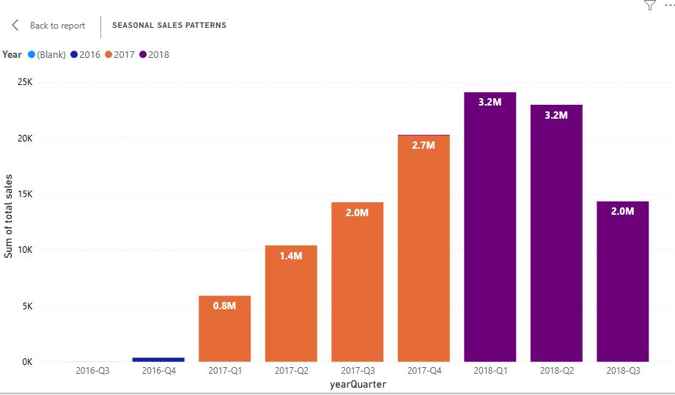

sType : “Line and stacked column Chart”

X-axis : yearQuarter

Colum Y-axis : Count of Total Revenue

Column Legend: Order approved at Quarter

**Formula:**

yearQuarter = FORMAT(' orders_dataset (1)'[order_purchase_timestamp].[Date], "yyyy") & "-" & FORMAT(' orders_dataset (1)'[Quarter],"0")

Total Revenue = order_items_dataset[order_item_id]* order_items_dataset[price]

**Insight:** The line chart visualizes quarterly sales trends from 2016 to 2018, highlighting seasonal patterns. In 2018, sales peaked in Q2 at 2.86M before dropping to 1.70M in Q3, indicating possible seasonal decline. Conversely, 2017 shows a steady upward trend, rising from 0.74M in Q1 to 2.42M in Q4, suggesting consistent growth throughout the year. Data for 2016 is minimal, showing only a slight increase in Q4. These patterns help identify strong quarters for planning inventory, marketing, and staffing. Recognizing sales fluctuations across quarters is crucial for forecasting and aligning business strategies with seasonal demand.

**8. Revenue Analysis:**

Determine the Total revenue generated by ShopNest store and analyze how it changes over time (yearly). Represent this information through suitable visuals to highlight trends and patterns.

Visualization Used :

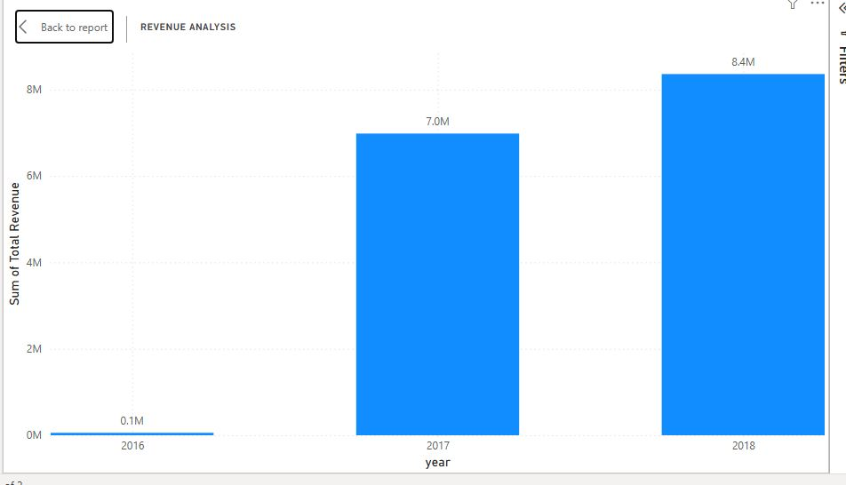

Type: “Stacked column Chart”

X-axis: year

Y-axis: sum of Total Revenue

**Formula:**

Total Revenue = order_items_dataset[order_item_id]* order_items_dataset[price]

**Insight:** The line chart illustrates the total annual revenue for ShopNest from 2016 to 2018. Starting from nearly zero in 2016, the revenue sharply increases to approximately 7 million in 2017, indicating a major growth phase. The upward trend continues in 2018, reaching over 8 million, although the growth rate is slightly slower than the previous year. This steady increase reflects successful business scaling, customer acquisition, and product performance. The visual highlights key revenue milestones and provides a clear picture of the company’s financial trajectory, which can inform budgeting, forecasting, and strategic planning.

**Conclusion:**

The comprehensive analysis presented in this Power BI dashboard offers valuable insights into ShopNest's retail operations. Key findings highlight the top-performing product categories, such as bed_bath_table, health_beauty, and sports_leisure, which contribute significantly to overall sales revenue. The delayed order analysis reveals opportunities to improve delivery efficiency, especially in certain categories with higher delay rates.

The payment method analysis shows that customers predominantly prefer specific payment modes, guiding decisions for optimizing the checkout process. Product rating insights have identified the most and least appreciated products, providing direction for quality improvement and inventory decisions. Additionally, state-wise sales performance sheds light on regional strengths and weaknesses, while quarterly trends indicate seasonal buying behaviours that can inform promotional strategies.

Lastly, the yearly revenue analysis reflects consistent growth, underlining the brand's expanding market presence. Overall, this dashboard empowers data-driven decision-making, enabling stakeholders to enhance customer satisfaction, operational efficiency, and business profitability.

**Dashboard Snapshot:**

